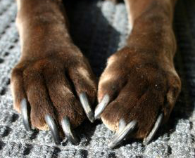
We see them every day, in sets of four usually, but sometimes 5 or even 6. Multiply that by 4 legs and it adds up to a lot of nails that we see, clip and address with clients each and every day.
But do we really understand all that we should about these incredible little appendages?
We should first realize the larger picture. Dogs walk on their toes like a horse, not on their pads or the "soles" of their feet like a human. So this puts weight dispersion and balance of the dog's entire mass on a very small center of impact absorption (especially if they are also overweight). Meaning that if they feel pain in a toe or a nail, they will then have to rock back on their heels and extend the ligaments of their larger pad and the back of their ankles to try to ease the pain in their toes. This puts them at a tremendous risk of injuring their ankles, elbows, hocks, shoulder and hips, as well as their connective tissues such as ACLs. Everything in one's musculoskeletal system is connected with every other part of the body. So, simple overgrown nails can be the root of not only much discomfort, but much financial expense in the long run.
Overgrown nails on a dog is one of the leading causes of obesity. If we really think about it, it is likely the leading cause.
Overgrown nails lead to discomfort of the bones and tendons and ligaments of the toes, then up to the larger bones and tissues of the foot, up the arms and legs and into the larger bones of the shoulders, hips and then on to the spine. Everything touches something else. And when one thing is out of line at the root of one's center of mobility, it puts everything else in the body out of sync, and therefore in some level of discomfort. After time, this leads to genuine physical deterioration and then to eventual disability. So, looking at the total structure of the dog, and in thinking about how we feel when our feet hurt or are injured, it is easy to see that the comfort and care of the feet and toes are at the forefront of one's most important necessities--both human and canine or feline.
We as people can address to our own needs and vocalize when we have pain to someone who can help. For dogs, they rely on their caregivers to take notice and give them relief. So, it is my belief that proper care and maintenance of a dog's toenails is on of the most important jobs and skills a groomer needs to have.
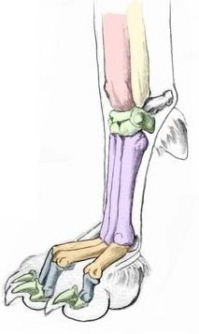
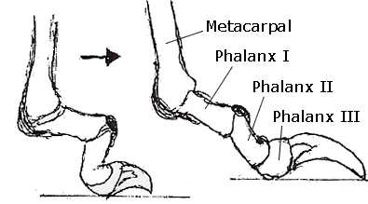
Canine Toenail Composition
The canine nail is comprised of 3 main parts. They are of the quick or the vein and nerve endings that supply both blood circulation and sensitivity to pressure and hot/cold senses of the toe and the foot.
Surrounding this very soft, fluid filled center is a pulp, inner nail bed, or layers of soft and moist tissue that helps to protect and cushion the sensitive vein and nerves much as our fatty tissue and subcutaneous makeup does for our own bodies. This area is slightly harder than the layers beneath it, yet still cannot be counted as the nail itself because it cannot protect the quick of the nail when exposed. This area is also what is visible in a light colored nail as the darker circle or half moon shape when we trim back the nail and get closer to the quick. On dark nails it can be nearly impossible to see, but it does make a different sound in the nail trimmers when clipped into. This area feels pressure and will often cause the dog to begin to pull back as it feels this pressure and anticipates possible pain.
Around these inner layers is a harder more durable wrap of many layers of protein and keratin- or fibrous structural proteins that are tough and insoluable. These layers make up the nail and round out its full length.
In the picture below, you can see the cross section of the nail bed, and the bit of moisture in its center.
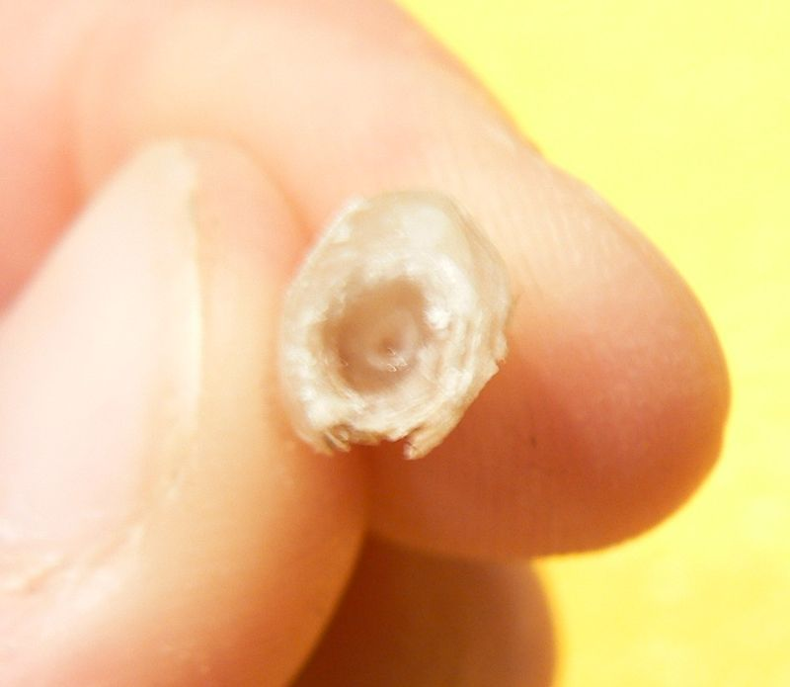
In the pictures below you can see the layers forming the inner and outer portion of the nail and how they grow out in rings and wrap around the nail, creating its shape. Notice that this nail is quite overgrown.
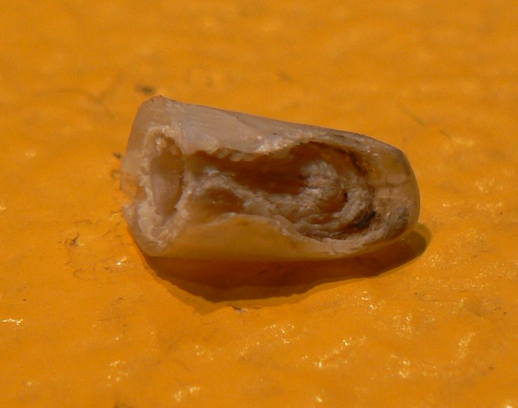
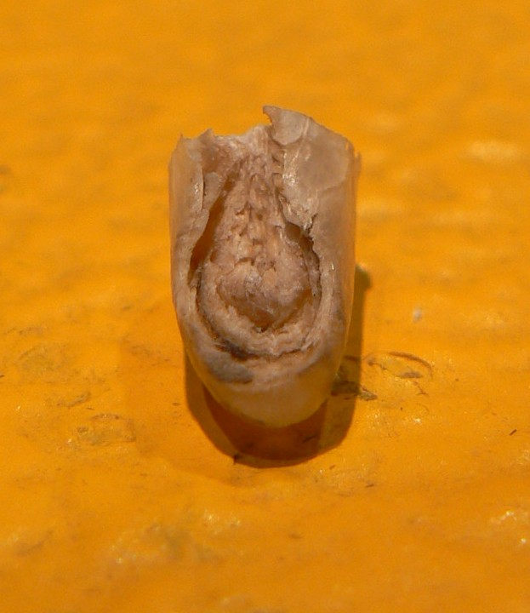
So , looking at these photos, we can clearly see how important it is to keep nails trimmed up as short as possible to avoid the inner quick from getting too long, and therefore the nail growing out ahead of it too far.
Look at this photo of a dog's foot with overgrown nails.
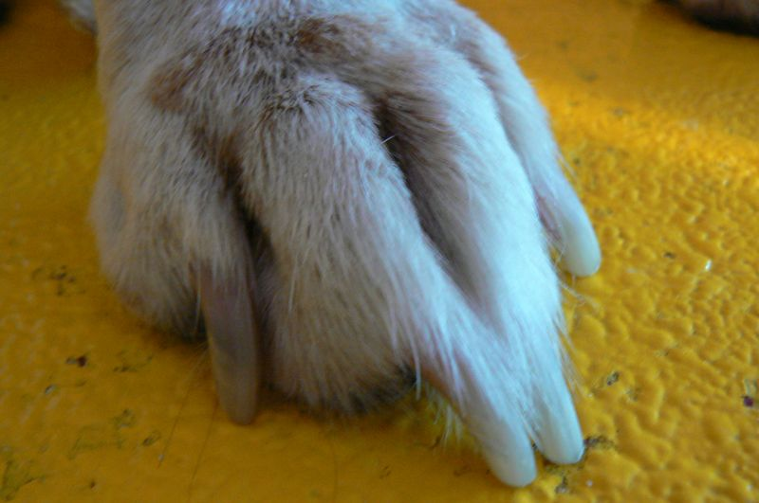
Can you see the extension of the foot, the lengthening of the toes and how the weight is being bared on the back of the foot? This is what creates pain, difference in weight distribution and eventual physical issues.
Proper Clipping if the nail
For clipping the nails--everyone does do it differently so this technique might not work for you,,but it is the best way I have found for myself.
I will always clip the nails as soon after or nearest to the pet's arrival as possible, before the bath- not just in case I quick a nail, but also because elevated blood pressure actually surges blood flow into extremities--included the toes, so it will be possible to clip a nail SHORTER if the nail is clipped before the dog sits and works itself up (if it is anxious) or before the bath- as the elevated water temp. also elevates the dog's core temp. and therefore increases circulation.
For me personally, I have found it works best to bring the foot softly back under the dog so that the elbow is tight to the pet's side, and the foot is not too overly bent at the ankle- in case the pet has stiffness there from age, etc. This can be tough though, depending on the size of the dog and if working on a stationary table.
Why hold the foot back instead of forward? First, you're back away from the dog's mouth and range of view. Also, holding the foot out away from the dog encourages them to pull, you to then squeeze or to equal their pull with yours, and for you to have a less steady foot for cutting the nails. Also, if is proven that tucking up the foot does help dampen the nerve endings of the toes and therefore they may be less sensitive for the feel of the clipping. If you clip a nail on a dog out in front of their body--listen to the sound that the nail makes when you clip. Listen to it when you clip- the sound will be noticeably quieter when the foot is tucked up. Some dogs just fear that "kajunk!" sound the clippers make.
After lifting the foot back and slightly up, then I clip the nails back, straight up & down, until I see the little dark spot in the center of the nail that signals the beginning of the soft spongy tissue that encapsulates the actual vein. With some dogs like those who are old and lack the softness in the center of the nail (this happens from loss of circulation, trauma to the nail bed after years of overgrown nails, or an ongoing low grade nail fungus) it is harder to tell the beginning of this soft area, so even after all of these years, I'll find myself sometimes still taking off a sliver at a time until I see the spot. Cutting the nail straight up & down pulls the angle of the nail up and back from the floor when the pet's foot is down, therefore helping to keep the nails' not "ticking" on the floor to last longer. You can also go back over the nails and clip off the left and right side of the nail to soften the ends and give a "pedicured" look, and of course, clipping first and them going over the nails with a Dremmel will pull the quick back even more and give each nail a soft tip. This is my technique, and it will likely work great for you.
The guide below shows the angles that I use the clippers to take length off. Clipping the nail at these angles also encourages the quick to "die back" and therefore each trimming session will result in a shorter nail.
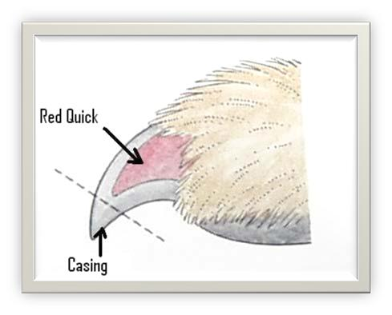
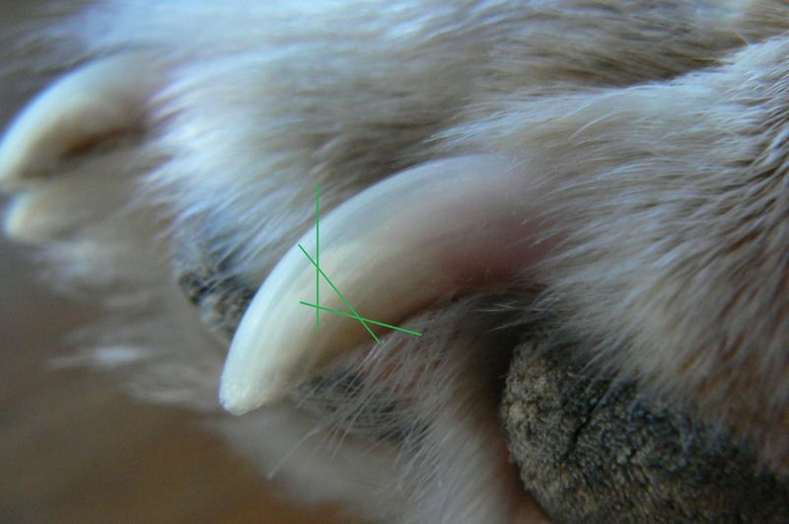
And here is a photo of a clipped set of nails. This dog will need to come in about every other week for a few clips to get the nails back a little more each time.
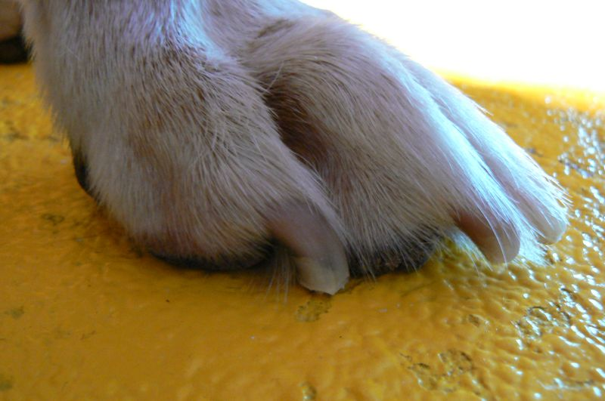
Below is a photo of a clipped set of nails next the an unclipped foot--can you see how already the weight is more up on toe and how the nails are away from the floor even though they still need to be gotten shorter?
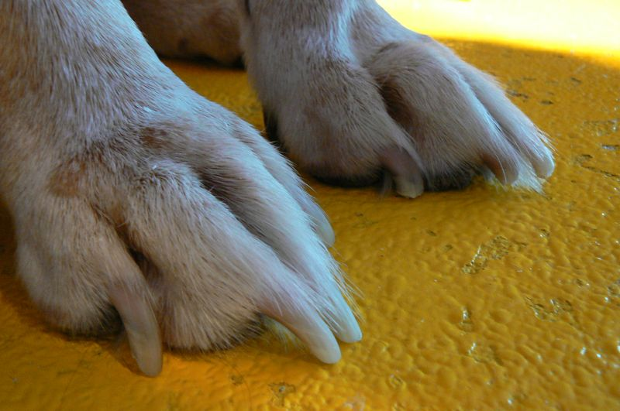
There is a world of information that goes into any thing that we do in our salons day to day, understanding how a dog's nails are comprised, and how to properly care for them, and how important it is to talk with clients about proper nail and foot care for their pets, will help us to provide for a better overall quality of life for each and every one of our clients!
And don't forget to care for their pads as well! Feel free to read up on my homemade recipe for a wonderful pad and pad treatment, or check out my full line of Canine Spa Therapy products available for not just feet, but all areas that need extra TLC!
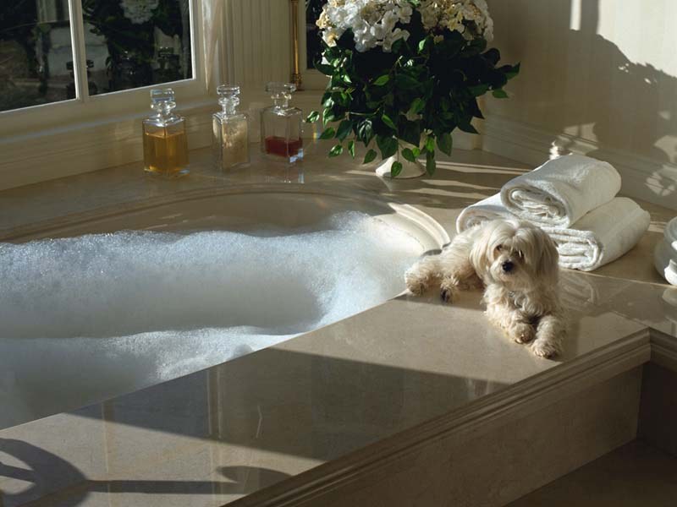
click the photo to view my site!
Happy Pawdicuring!
